**NAMA : RIFKI MAULANA**

**KELAS : TI VC**

**NIM : A2.2100111**

MP. PENGEMBANGAN APLIKASI PLATFORM KHUSUS | HASIL PEMBELAJARAN MODUL 6 PERTEMUAN 6

1. Membuat directory baru Kalkulator

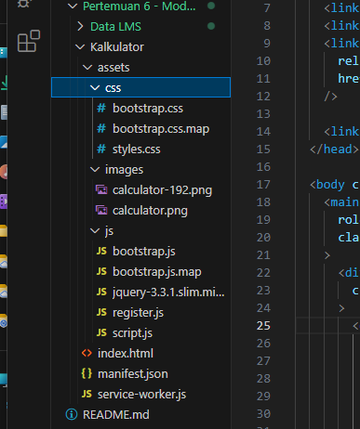

1. Code index.html
2. <!DOCTYPE html>
3. <html lang="en">
4. <head>
5. <meta charset="UTF-8" />
6. <meta name="viewport" content="width=device-width, initial-scale=1.0" />
7. <title>App Kalkulator Sederhana</title>
8. <link rel="stylesheet" type="text/css" href="assets/css/bootstrap.css" />
9. <link rel="stylesheet" type="text/css" href="assets/css/styles.css" />
10. <link
11. rel="stylesheet"
12. href="https://fonts.googleapis.com/css?family=Open+Sans:600,700"
13. />
14. <link rel="manifest" href="manifest.json" />
15. </head>
16. <body class="align-items-start pt-0 flex-column">
17. <main
18. role="main"
19. class="container-fluid col-xl-4 col-lg-4 col-md-6 col-sm-12 col-12 pt-0 pl-0 pr-0"
20. >
21. <div
22. class="container-user d-flex flex-row justify-content-between px-3 py-4"
23. >
24. <div class="content-text flex-xolumn w-100">
25. <p class="bodytext2 color-black500 p-0 m-0" id="dataName">
26. Selamat Datang
27. </p>
28. <p class="headline6 color-black500 semibold p-0 m-0">
29. App Kalkulator Sederhana
30. </p>
31. </div>
32. <a class="content-image-profile flex-shrink" href="profile">
33. <div class="frame-image">
34. <img
35. src="assets/images/calculator.png"
36. alt="profile"
37. srcset=""
38. id="dataImage"
39. />
40. </div>
41. </a>
42. </div>
43. <div id="calculator">
44. <div id="result">
45. <div id="history">
46. <p id="history-value"></p>
47. </div>
48. <div id="output">
49. <p id="output-values"></p>
50. </div>
51. </div>
52. <div class="container-fluid">
53. <div class="row mb-3">
54. <div class="col-3 col-xs-3">
55. <button
56. class="btn btn-danger btn-circle btn-xl operator"
57. id="clear"
58. >
59. C
60. </button>
61. </div>
62. <div class="col-3 col-xs-3">
63. <button
64. class="btn btn-danger btn-circle btn-xl operator"
65. id="backspace"
66. >
67. CE
68. </button>
69. </div>
70. <div class="col-3 col-xs-3">
71. <button
72. class="btn btn-dark btn-circle btn-xl operator"
73. id="percent"
74. >
75. %
76. </button>
77. </div>
78. <div class="col-3 col-xs-3">
79. <button
80. class="btn btn-dark btn-circle btn-xl operator"
81. id="divide"
82. >
83. /
84. </button>
85. </div>
86. </div>
87. <div class="row mb-3">
88. <div class="col-3 col-xs-3">
89. <button class="btn btn-gray btn-circle btn-xl number" id="7">
90. 7
91. </button>
92. </div>
93. <div class="col-3 col-xs-3">
94. <button class="btn btn-gray btn-circle btn-xl number" id="8">
95. 8
96. </button>
97. </div>
98. <div class="col-3 col-xs-3">
99. <button class="btn btn-gray btn-circle btn-xl number" id="9">
100. 9
101. </button>
102. </div>
103. <div class="col-3 col-xs-3">
104. <button class="btn btn-dark btn-circle btn-xl operator" id="*">
105. &times;
106. </button>
107. </div>
108. </div>
109. <div class="row mb-3">
110. <div class="col-3 col-xs-3">
111. <button class="btn btn-gray btn-circle btn-xl number" id="4">
112. 4
113. </button>
114. </div>
115. <div class="col-3 col-xs-3">
116. <button class="btn btn-gray btn-circle btn-xl number" id="5">
117. 5
118. </button>
119. </div>
120. <div class="col-3 col-xs-3">
121. <button class="btn btn-gray btn-circle btn-xl number" id="6">
122. 6
123. </button>
124. </div>
125. <div class="col-3 col-xs-3">
126. <button class="btn btn-dark btn-circle btn-xl operator" id="-">
127. -
128. </button>
129. </div>
130. </div>
131. <div class="row mb-3">
132. <div class="col-3 col-xs-3">
133. <button class="btn btn-gray btn-circle btn-xl number" id="1">
134. 1
135. </button>
136. </div>
137. <div class="col-3 col-xs-3">
138. <button class="btn btn-gray btn-circle btn-xl number" id="2">
139. 2
140. </button>
141. </div>
142. <div class="col-3 col-xs-3">
143. <button class="btn btn-gray btn-circle btn-xl number" id="3">
144. 3
145. </button>
146. </div>
147. <div class="col-3 col-xs-3">
148. <button class="btn btn-dark btn-circle btn-xl operator" id="+">
149. +
150. </button>
151. </div>
152. </div>
153. <div class="row mb-3">
154. <div class="col-3 col-xs-3">
155. <button
156. class="btn btn-gray btn-circle btn-xl empty"
157. id="empty"
158. ></button>
159. </div>
160. <div class="col-3 col-xs-3">
161. <button class="btn btn-gray btn-circle btn-xl number" id="0">
162. 0
163. </button>
164. </div>
165. <div class="col-3 col-xs-3">
166. <button
167. class="btn btn-gray btn-circle btn-xl empty"
168. id="empty"
169. ></button>
170. </div>
171. <div class="col-3 col-xs-3">
172. <button class="btn btn-warning btn-circle btn-xl operator" id="=">
173. =
174. </button>
175. </div>
176. </div>
177. </div>
178. </div>
179. </main>
180. <script src="assets/js/jquery-3.3.1.slim.min.js"></script>
181. <script src="assets/js/bootstrap.js"></script>
182. <script src="assets/js/script.js"></script>
183. <script src="assets/js/register.js"></script>
184. </body>
185. </html>
186. Install live server pada VS CODE

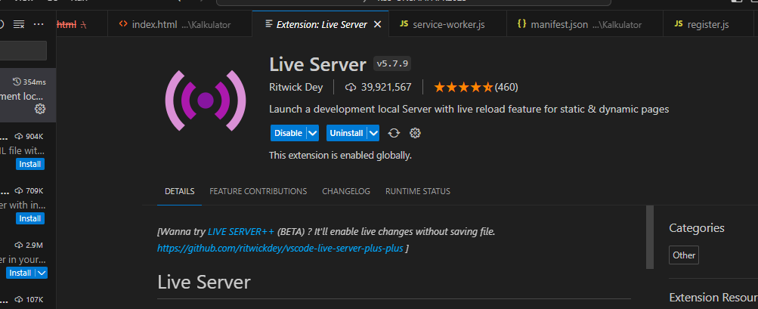

1. Tampilan index.html didalam menggunakan url live server

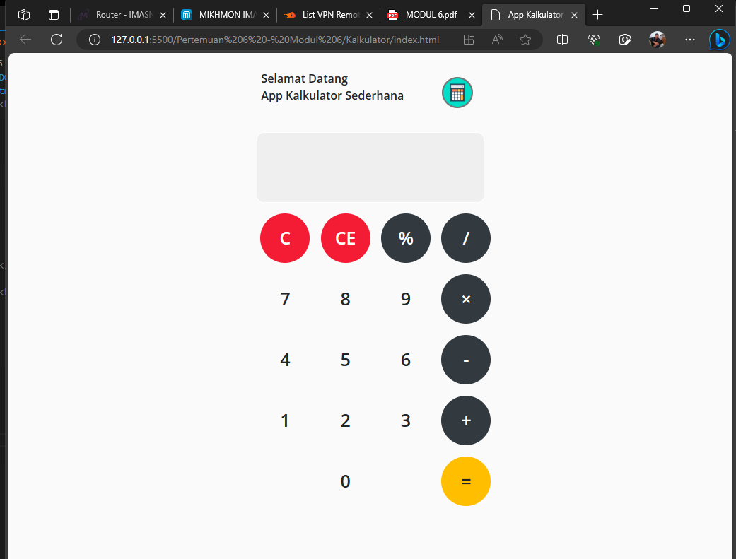

1. Code js/script.js
2. function getHistory() {
3. return document.getElementById("history-value").innerText;
4. }
5. function printHistory(num) {
6. document.getElementById("history-value").innerText = num;
7. }
8. function getOutput() {
9. return document.getElementById("output-values").innerText;
10. }
11. function printOutput(num) {
12. if (num == "") {
13. document.getElementById("output-values").innerText = num;
14. } else {
15. document.getElementById("output-values").innerText =
16. getFormattedNumber(num);
17. }
18. }
19. function getFormattedNumber(num) {
20. if (num == "-") {
21. return "";
22. }
23. var n = Number(num);
24. var value = n.toLocaleString("en");
25. return value;
26. }
27. function reverseNumberFormat(num) {
28. return Number(num.replace(/,/g, ""));
29. }
30. var operator = document.getElementsByClassName("operator");
31. for (var i = 0; i < operator.length; i++) {
32. operator[i].addEventListener("click", function () {
33. if (this.id == "clear") {
34. printHistory("");
35. printOutput("");
36. } else if (this.id == "backspace") {
37. var output = reverseNumberFormat(getOutput()).toString();
38. if (output) {
39. //if output has a value
40. output = output.substr(0, output.length - 1);
41. printOutput(output);
42. }
43. } else {
44. var output = getOutput();
45. var history = getHistory();
46. if (output == "" && history != "") {
47. if (isNaN(history[history.length - 1])) {
48. history = history.substr(0, history.length - 1);
49. }
50. }
51. if (output != "" || history != "") {
52. output = output == "" ? output : reverseNumberFormat(output);
53. history = history + output;
54. if (this.id == "=") {
55. var result = eval(history);
56. printOutput(result);
57. printHistory("");
58. } else {
59. history = history + this.id;
60. printHistory(history);
61. printOutput("");
62. }
63. }
64. }
65. });
66. }
67. var number = document.getElementsByClassName("number");
68. for (var i = 0; i < number.length; i++) {
69. number[i].addEventListener("click", function () {
70. var output = reverseNumberFormat(getOutput());
71. if (output != NaN) {
72. output = output + this.id;
73. printOutput(output);
74. }
75. });
76. }

5. code js/register.js

document.addEventListener("DOMContentLoaded", init, false);

function init() {

  if ("serviceWorker" in navigator && navigator.onLine) {

    navigator.serviceWorker.register("/service-worker.js").then(

      (reg) => {

        console.log("Registrasi service worker Berhasil", reg);

      },

      (err) => {

        console.error("Registrasi service worker Gagal", err);

      }

    );

  }

}

6. Menyisipkan js/script.js dan js/register.html pada index.html

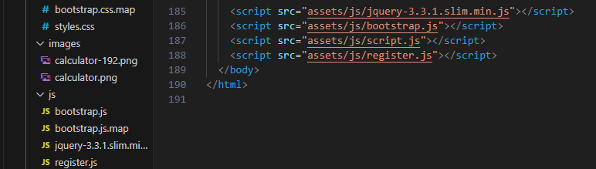

7. Membuat Manifest.json dan service-worker.js didalam directory: root atau /kalkulator



8. Code manifest.json

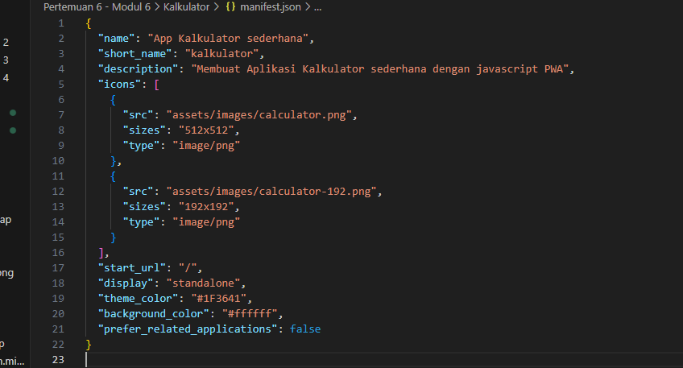

9. Code service-worker.html

const CACHE_NAME = "SW-001";

const toCache = [

  "/",

  "manifest.json",

  "assets/js/register.js",

  "assets/img/icon.png",

];

let deferredPrompt;

self.addEventListener("beforeinstallprompt", (e) => {

  e.preventDefault();

  deferredPrompt = e;

  showInstallPromotion();

});

self.addEventListener("install", function (event) {

  event.waitUntil(

    caches.open(CACHE_NAME).then(function (cache) {

      return cache.addAll(toCache);

    })

  );

});

self.addEventListener("fetch", function (event) {

  event.respondWith(

    fetch(event.request).catch(() => {

      return caches.open(CACHE_NAME).then((cache) => {

        return cache.match(event.request);

      });

    })

  );

});

self.addEventListener("activate", function (event) {

  event.waitUntil(

    caches.keys().then((keyList) => {

      return Promise.all(

        keyList.map((key) => {

          if (key !== CACHE_NAME) {

            console.log("[ServiceWorker] Hapus cache lama", key);

            return caches.delete(key);

          }

        })

      );

    })

  );

});

10. Langkah terakhir adalah menjalankan kembali program dengan live server

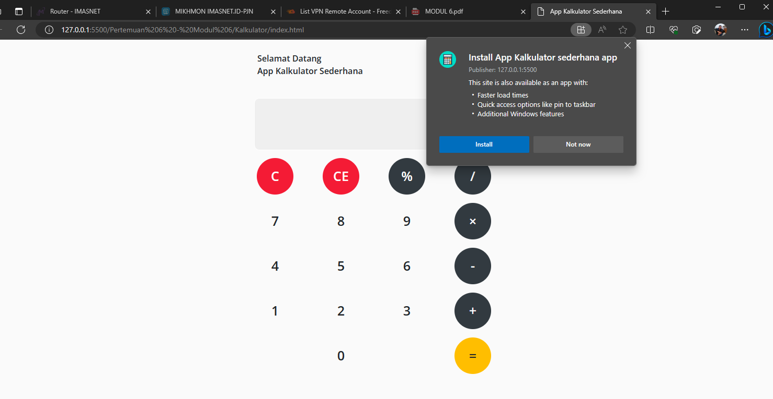

11. Uci coba menjalankan program melalui smartphone

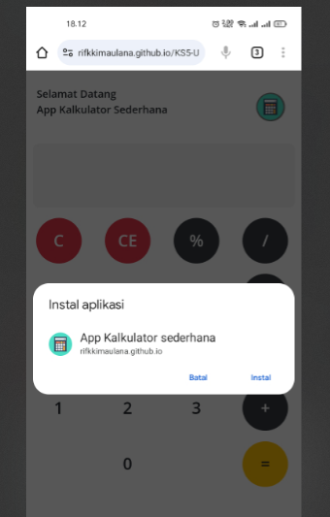 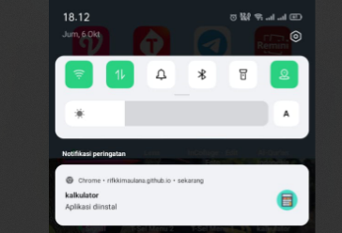

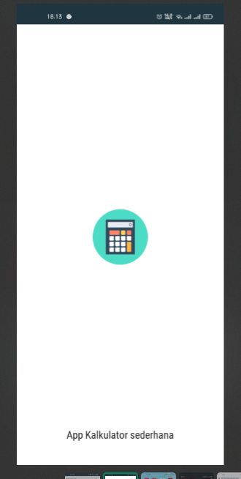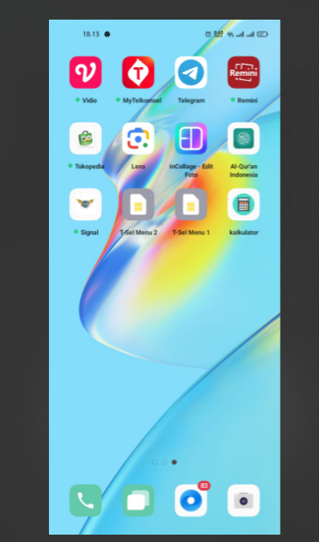  
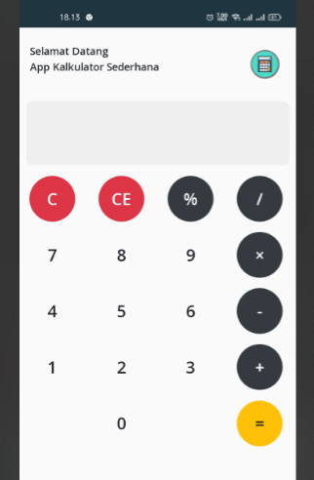

TERIMAKASIH